Comparative Analysis of ROI Measurement Methods for CTCF Calculation: Fiji vs R
RUMO BIAN
Faculty of Engineering and Information Technology, University of Technology Sydney
WEI DENG
25th May 2025

Abstract
This report presents a comparative analysis of two methodological approaches for quantifying Corrected Total Cell Fluorescence (CTCF) in fluorescence microscopy images: a conventional manual measurement using Fiji (ImageJ) and an automated workflow implemented in R using Fiji-exported ROI files. The study outlines the procedures of each method, discusses the theoretical basis behind the CTCF calculation, and evaluates the consistency between the two approaches. Results indicate that, when image pre‐processing and ROI selection are carefully standardized, both methods yield comparable measurements for Area, Mean, and Integrated Density values. Minor discrepancies are attributed to differences in ROI boundary delineation and data normalization procedures. The report concludes by highlighting the advantages and limitations of each method and offers recommendations for researchers engaged in image analysis.
Keywords: Fluorescence microscopy, ROI measurement, Cell Fluorescence, Fiji, R, image analysis.

1. Introduction

1.1 Background of Fluorescence Quantification

In recent years, quantitative analysis of fluorescence microscopy images has become increasingly important in cell biology research. By measuring the intensity of fluorescent signals in cells, researchers can quantify the expression and distribution of target molecules and compare differences between different treatments or conditions. Quantitative fluorescence microscopy is considered a powerful tool because it can transform qualitative observations into numerical data, which is essential for conducting reliable statistical analyses (Hobson et al., 2022).

A common method in fluorescence quantification is to measure the pixel intensity within a specific region of interest (ROI) on an image (Sinhal, Sharma, Ansari, & Bajaj, 2022). ROI refers to the area that researchers want to analyze, such as an entire cell or a specific structure within a cell. Modern image analysis software (such as ImageJ or Fiji) allows users to manually draw or define ROIs, or automatically generate ROIs by setting intensity thresholds. By focusing on the ROI, the signal from individual cells or structures can be distinguished from irrelevant background areas, resulting in more meaningful intensity measurements.

1.2 Application of CTCF in fluorescence quantitative analysis

In order to ensure the accuracy of fluorescence quantification, background subtraction is usually performed by calculating the corrected total cell fluorescence (CTCF). CTCF was defined as the integrated fluorescence intensity within the cell ROI minus the cell area multiplied by the mean fluorescence value of the background ROI. This metric corrects for background noise and differences in cell size, allowing for a more reliable estimate of true cellular fluorescence intensity. For example, without this correction, smaller cells may appear to have higher intensities simply because the fluorescence signal is concentrated in a smaller area. Therefore, it has become standard practice to employ CTCF in fluorescence image analysis to obtain comparable and unbiased results between different samples.

1.3 Research Aim

Currently, there are multiple software tools available for fluorescence image analysis, each with a different workflow. Fiji (ImageJ) is one of the most widely used platforms and is considered a standard tool in the field of scientific image analysis. It provides user-friendly features for ROI selection and intensity measurement, but its typical use involves semi-automatic steps (e.g., manual drawing of ROIs or use of macros). These manual operations are time consuming and may introduce errors between different users.

In contrast, programming environments such as R enable fully automated image analysis pipelines. For example, the EBImage package for R allows batch processing of large numbers of images in a consistent manner. Automated analysis can greatly increase processing efficiency and throughput and improve the reproducibility of fluorescence quantitation results by applying consistent guidelines across the entire data set.

Despite the availability of a variety of tools, the results obtained from different analytical methods are not necessarily directly comparable to each other. Semi-automated ROI measurements in Fiji and script-driven analysis in R may produce discrepancies in CTCF values. The reasons may lie in differences in ROI identification accuracy, background subtraction methods, or user bias. This uncertainty highlights the need for a direct comparison of the two methods. This study aims to address this need by systematically comparing the performance of Fiji and R in CTCF quantitative analysis. We selected fluorescence microscopy images of cells treated for 1 h, 2 h, and 4 h for analysis, with each condition containing two images. Importantly, in both the Fiji and R analyses, we applied the same batch of ROIs (26 cell ROIs and 3 background ROIs) to each image to ensure that differences in results were only due to the measurement method itself and not differences in ROI selection. The aim of our study was to evaluate the consistency and reliability of Fiji and R in ROI-based CTCF calculations and to identify significant differences. Elucidating these differences will help guide researchers in selecting appropriate quantitative fluorescence image analysis methods and increase confidence in the results of fluorescence data comparisons.

2. Literature Review

2.1 Development of fluorescence microscopy and quantitative techniques

Fluorescence microscopy has evolved from an early tool for mainly qualitative observation to an important means of quantitative analysis. Traditionally, fluorescent labels can only provide qualitative visual information; however, with the improvement of probe fluorescence stability and the advancement of imaging technology (especially confocal microscopy), researchers can now perform rigorous quantitative analysis of fluorescence data (Suzuki, Matsuzaki, Hagiwara, Aoki, & Takata, 2007). In fact, the trend of modern life science research requires the quantification of fluorescence signals rather than just qualitative description. These demands are driving a shift in microscopic imaging toward higher accuracy and data richness. For example, new generations of detectors have higher sensitivity and dynamic range, allowing even weak signals to be measured and compared across experiments. The advent of real-time live-cell imaging techniques, such as advanced time-lapse imaging and super-resolution microscopy, has further expanded the ability to quantitatively observe cellular processes. These developments have led to "increasing emphasis on the quantitative aspects of fluorescence microscopy. (Sasaki, 2021)" Researchers are increasingly measuring fluorescence intensity to infer biological parameters such as molecular concentrations and interaction dynamics.

The shift to quantitative microscopy has been driven by advances in both hardware and image analysis methods. New microscopy modes such as spinning disk confocal, two-photon excitation, light sheet microscopy, and super-resolution microscopy provide higher resolution and signal-to-noise ratios, allowing for more precise measurements of pixel intensity (Hamilton, 2009). It is recognized that results obtained from different microscopes or analytical methods are often difficult to directly compare due to differences in instrumentation and procedures. However, these complex imaging systems also bring new challenges - for example, super-resolution microscopy has complex optics and algorithms (Schermelleh et al., 2019). If the experimental conditions or settings are not appropriate, the image quality will be significantly degraded and the quantitative results may be inaccurate. Therefore, to fully utilize such advanced imaging techniques for quantitative analysis, strict calibration and standardized operating procedures must be followed. On the software side, advances in digital image processing have greatly improved the efficiency of data extraction: researchers can now acquire high-resolution images and use computational tools to extract numerical data (such as the fluorescence intensity of each organelle or protein cluster). With the help of these methods, phenomena that were previously difficult to quantitatively evaluate with the naked eye can be measured, such as protein expression levels within individual cells, the number of stained cells or fluorescent spots, and the colocalization ratio. Quantitative image analysis can also go beyond population averages and reveal some counterintuitive biological phenomena through single-cell measurements (Di Carlo & Lee, 2006). Overall, the enhanced sensitivity of camera detectors, improved image analysis algorithms, and increased computing power have made fluorescence microscopy not only a beautiful image but also a scientific tool that can obtain a large amount of quantitative data (Wolf & D.E.,2007).

While making the above progress, improving the reliability and comparability of fluorescence quantitative results has also become a key issue (Waters, 2009). As more and more laboratories adopt quantitative imaging, people realize that due to differences in instruments and processes, the results obtained by different microscopes or analytical methods are often difficult to directly compare.For example, if two microscopes have different detector sensitivities and calibrations, they may measure very different intensity values ​​even for the same sample (Dunn, Kamocka, & McDonald, 2011). In the early days, the development of various image quantification methods was relatively scattered, resulting in different standards for data processing in different studies (Oberholzer, Östreicher, Christen, & Brühlmann, 1996). In response to this, the field of microscopy imaging has begun to pay attention to standardization and calibration. In recent years, standard calibration materials for fluorescence quantification (such as fluorescent slides with known patterns, DNA origami reference probes, etc.) have emerged to help researchers normalize intensity readings between different platforms (Schmied et al., 2014). In 2019, the international standard ISO 21073:2019 for confocal microscopy measurements was published (Nelson et al., 2020). In parallel, several community-driven initiatives have been established (Boehm et al., 2021). To improve the reproducibility of fluorescence microscopy data, recommendations have been made on everything from light source stability and detector performance to image analysis standards (Sasaki, 2022).

2.2 Image analysis method and application based on ROI

When doing fluorescence image quantification, researchers usually draw a ROI first (Nieto-Castanon et al., 2003). Only extract the value of that piece, such as average grayscale, total fluorescence intensity or pixel area, etc. (Smal et al., 2010). There are several ways to draw ROI: the most direct way is to draw a line manually, such as using a circle or polygon to circle the target cell structure (Kichuk, 2023). Another way is to let the software automatically generate ROI according to the threshold value - as long as the pixel brightness is higher than the set value, those areas will be automatically selected (Jiang, Wang, & Liu, 2015). This threshold method is particularly convenient for finding cell nuclei, because the software will circle all bright areas exceeding the threshold at once (Eppel, 2018). Each ROI determination method has its applicable scenarios: manual ROI is highly flexible and suitable for complex or irregularly shaped structures; threshold Auto ROI excels in high-throughput analysis and provides unbiased selection of targets with significant signal differences (Buchser et al., 2014).

Regardless of the method used to define the ROI, the core principle is to extract the signal region of interest from the image for measurement. By focusing on a specific area (a single cell in a tissue section, or a part of a cell such as the nucleus), researchers can obtain meaningful quantitative parameters (Loukas et al., 2003). For example, you can measure the average fluorescence intensity of the target protein in the region, the total integrated fluorescence intensity in the region, the area size of a fluorescently labeled structure, or count the number of fluorescent targets (if each target is defined as a ROI). This is actually a relative quantitative method - comparing the intensity of one ROI to the intensity of another ROI (Krak et al., 2005). For this comparison to be reliable, it is important that the images are acquired under identical imaging parameters (e.g. uniform exposure time, gain, etc.) and that the measurements are performed on raw, uncompressed and unprocessed images (Abdullah, 2016). Another consideration is how the size and position of the ROI affects the measurement results. If the ROI is drawn too large, or includes non-luminous areas outside the target structure, then the non-signal area will lower the average intensity value (Mousavi, Naghsh, & Abu-Bakar, 2015).

Specifically, examples of ROI analysis include measuring the mean fluorescence intensity (MFI) of a protein within a defined tissue region and comparing the level of that protein between a treated group and a control group or select multiple ROIs in a tissue section to count the number of nuclei in the field of view and determine what percentage of them carry the target fluorescent marker (positive cell ratio) (Chu et al., 2014). In summary, the ROI approach provides a structured means for image analysis that can extract and quantify specific features from complex fluorescence images.

2.3 The role of Fiji and R in fluorescence image quantification

Open-source software tools have become integral to the quantitative analysis of fluorescence images, with Fiji and R playing important and complementary roles in a typical workflow. Fiji ("Fiji is ImageJ") is a popular distribution of ImageJ optimized for biological image analysis. It provides an intuitive visual interface that supports point-and-click image viewing and processing, while also meeting advanced automation needs through extensive plugins and scripting capabilities (Schindelin et al., 2012). The advantage of Fiji lies in its combination of powerful image processing capabilities and good ease of use, which makes it easy for researchers without a deep programming background to use it. Fiji integrates many useful functions for fluorescence quantification by default: for example, drawing and measuring ROIs, applying intensity thresholds, performing background subtraction, and batch processing of images through macros (Stossi & Singh, 2023). With Fiji, scientists can convert raw microscopic images into measurable values. These operations can be done interactively (manually stepping through menu commands) or automated with the help of macros for higher throughput (Vosatka, Lavenus, & Logue, 2022). Fiji has a rich plugin ecosystem, which means that many specialized analyses (such as colocalization analysis, particle counting, 3D volume measurement, etc.) can be achieved by installing plugins. Because Fiji is built on the ImageJ platform, it encourages rapid prototyping of new image analysis algorithms and sharing these algorithm plugins to users through an integrated update system.

The R language and its ecosystem play a role in the backend of image data analysis (Giorgi, Ceraolo, & Mercatelli, 2022). R is often known for its data analysis and statistical capabilities, but through packages such as EBImage, R can also be used for image processing and quantitative (Pau et al., 2010). BImage (an open source package provided by Bioconductor) provides R with functions for reading microscopic images, processing images (such as filtering and adjustment), segmenting objects (such as identifying cells or cell nuclei), and extracting quantitative indicators from these objects (Sklyar & Huber, 2008). With EBImage, R can programmatically automate the various steps of fluorescence image quantification. One of the great advantages of R is that it closely links image analysis with statistical modeling. It allows users to process the results immediately after extracting fluorescence data using R’s rich statistical tools, machine learning algorithms, and data visualization techniques (Carpenter et al., 2006). In short, R provides a programmable and reproducible analysis method: every step from image reading to result output can be implemented through scripts, which greatly improves the reproducibility and scalability of the analysis.

In practical applications, the roles of Fiji and R are often complementary. Fiji excels at interactive data exploration and general image processing, making it well suited for the initial stages of analysis or for medium-sized datasets. R is often used in situations where the amount of data or the complexity of the analysis is high. In high-throughput experiments involving dozens or hundreds of images (such as large-scale drug screening involving multiple fields of view), the pipeline built by R can systematically process all images without manual intervention, thereby reducing human variation. As fluorescence microscopy datasets continue to grow in size and complexity, the clever use of tools such as Fiji and R will ensure that we not only acquire image data, but also quantify and analyze them appropriately to draw reliable biological conclusions (Carpenter et al., 2006)

2.4 Common Problems in ROI Measurement and CTCF Analysis

Inconsistent image acquisition conditions: In quantitative fluorescence analysis, unstable imaging conditions are one of the main problems. Differences in settings such as exposure time, light intensity, or detector sensitivity in microscopy experiments can significantly affect the fluorescence intensity measured in the ROI (Tsikritsis et al., 2022). Data acquired under different conditions are difficult to directly compare, which impairs the reliability and reproducibility of CTCF measurements. Therefore, quantitative fluorescence microscopy requires strict uniformity of imaging parameters—even slight changes in settings can introduce errors (Tsikritsis et al., 2022). In fact, some experts emphasize that accurate fluorescence quantification requires strict control of system parameters and a full understanding of the limitations of the imaging system (Waters, 2009).

Manually drawing regions of interest (ROIs) is inherently subjective: different observers may choose slightly different ROI boundaries, introducing bias. D Manual ROI selection without a clearly defined process often introduces observer-dependent bias and leads to reduced reproducibility of results (Hoogstins et al., 2019). Therefore, inconsistent ROI placement can significantly increase the uncertainty of quantitative results.

Furthermore, the above problems are more prominent when calculating the corrected total cellular fluorescence (CTCF): Since the background signal is not uniform, it is very difficult to select a suitable background area. Different background ROI selections can significantly change the mean and variance of the background signal, making the calculated fluorescence contrast index also susceptible to selection bias (Hoogstins et al., 2019). A common optimization measure is to select multiple background areas in the image and take their average intensity for subtraction to improve the calculation accuracy (Shihan et al., 2021). These difficulties in CTCF calculations can be overcome by implementing a consistent background correction strategy combined with careful ROI selection, resulting in more reliable fluorescence quantification results.

3. Methods

3 .1 Experimental samples and fluorescence imaging
Cell samples were imaged 1 hour, 2 hours, and 4 hours after treatment. Samples were photographed using a fluorescence microscope at each time point. Each resulting image contains two channels: a green fluorescent channel highlights the target signal of interest, and a blue fluorescent channel (e.g. DAPI staining) identifies cell nuclei. Two representative images were acquired at each time point, resulting in a total of 6 images for analysis. All images were saved in an uncompressed 8-bit format to ensure that quantitative intensity information was not lost. Figures 1-6 show representative fluorescence images at 1 h, 2 h, and 4 h, where the ROI area is marked with a yellow polygon outline.
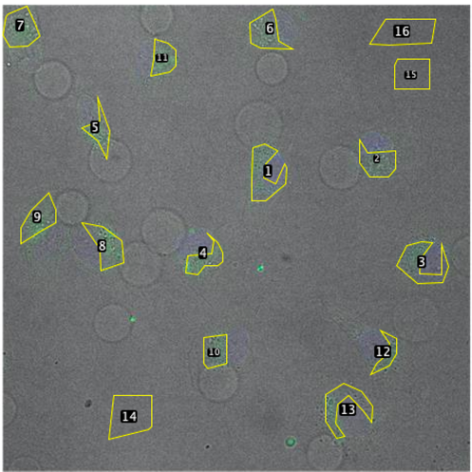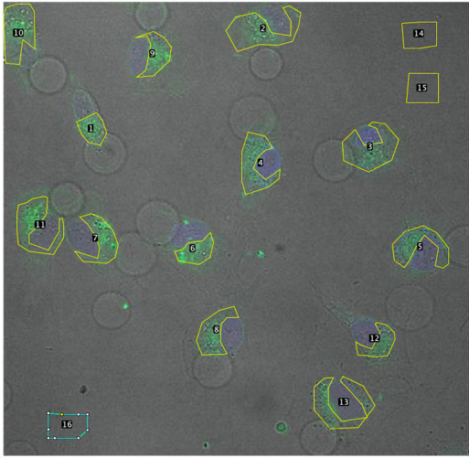
Figure 1-2, 1h ROI area marked with yellow polygon outline
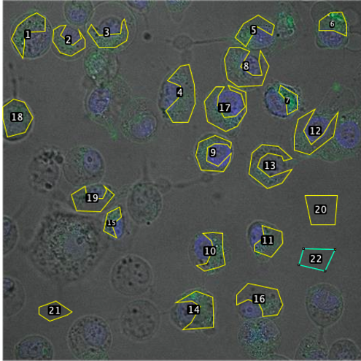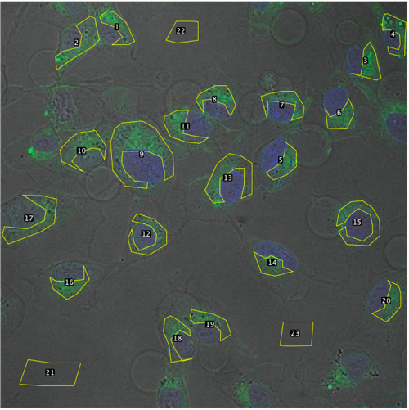
Figure 3-4, 2h ROI area marked with yellow polygon outline
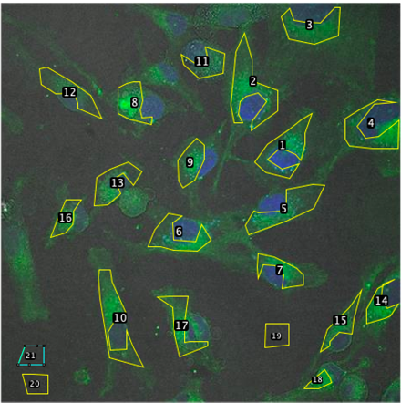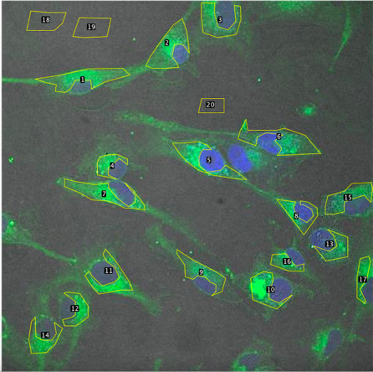
Figure 5-6, 4h ROI area marked with yellow polygon outline

3.2 ROI annotation and image preprocessing
Before fluorescence intensity measurement, ROI annotation was performed on fluorescence images using Fiji (ImageJ). Use the polygonal selection tool to outline each cell region as a cell ROI, and select several background ROIs in the cell-free area. These ROI selections are saved in Fiji's ROI Manager for subsequent analysis. Each cellular ROI is labeled with a number, while background ROIs have "bg" added to their names to distinguish them from cellular regions.
Prior to quantitative analysis, images were minimally preprocessed to preserve original intensity values. Specifically, raw data from the green fluorescence channel were analyzed directly without any thresholding or filtering applied to the images. The blue channel (nuclear stain) was used only to aid in identifying cell location and was not used for intensity measurements. By using the unprocessed green channel for ROI measurements, this study avoided bias that could be introduced by image-level adjustments such as background subtraction or pseudo-color scaling.

3.3 Fluorescence quantitative analysis workflow based on Fiji and R
The study used two ROI fluorescence quantitative analysis processes: one was manual measurement using Fiji software, and the other was automatic analysis through R language scripts. For the Fiji workflow, the ROI set for each image was loaded into Fiji's ROI manager and measured using the multiple measurement functionality. Without applying a threshold to the images, metrics such as area, mean gray value, minimum/maximum intensity, and integrated intensity of each ROI on the green channel were recorded. Export the measurement results to a CSV file. The mean background intensity (bgMean) of the background ROI of each image was then calculated using spreadsheet software. The corrected total cellular fluorescence (CTCF) of each cell ROI was calculated using the formula CTCF = integrated intensity – (area × bgMean). Any CTCF with negative values ​​was flagged and excluded from further analysis to ensure data quality.
For the R process, we developed a custom R script to automate the analysis. (Appendix 1) The script loads the green channel image for each condition and its corresponding ROI file via the EBImage packages. The script converts the polygon coordinates of each ROI into a binary mask to extract pixel intensity, and calculates the area, mean gray value and integrated intensity of the ROI based on this. The background ROI was processed in the same way to calculate bgMean, and the CTCF of each cell ROI was calculated using the same formula as the Fiji method. The script then aggregates all the results into a CSV file and generates a bar graph.
Prism10 is used to generate a bar graph to compare the Fiji and R results.

4. Findings

4.1 Fiji Results
Using the Fiji analysis method, we obtained the CTCF dataset for each cell ROI at each time point. As shown in Table 1, in the 1-h treatment group, CTCF values ​​ranged from approximately 3,500 to 41,000, with most of the measured values ​​concentrated around 18,000–20,000. This indicates that the fluorescence intensity of cells was at a moderate level 1 hour after treatment. In contrast, the CTCF value distribution of the 2-hour group was wider, and the average value was slightly lower than that of the 1-hour group (see Table 1), suggesting that the fluorescence intensity may have fluctuated or decreased to a certain extent in the second hour after treatment.
In the 4-hour treatment group, CTCF values ​​measured by Fiji were significantly elevated, with many cells exceeding 30,000 (Table 1). Some of these samples even had values ​​exceeding 40,000, indicating a substantial accumulation of fluorescent signals with prolonged treatment time.
This upward trend is very clear in the Fiji bar chart shown in Figure 7: the bar in the 4-hour group is significantly higher than the 1-hour and 2-hour groups. Overall, the results of the Fiji method revealed a trend that changed over time: as the treatment time increased, the CTCF intensity gradually increased. In summary, the corrected total fluorescence intensity increased significantly from 1 to 4 h, indicating that the target fluorescence was cumulatively enhanced over time under the experimental conditions.
Table1. FIJI-1hr 2hr 4hr CTCF
1hr | 2hr | 4hr
18136.118 | 9672.06667 | 38887.3273
5578.46333 | 10494.5133 | 55660.6027
3539.196 | 13905.5733 | 22249.824
10417.7513 | 20113.2333 | 19539.166
9989.18067 | 7941.52 | 40342.2427
15295.8067 | 4458.45333 | 37193.7893
18749.7827 | 7330.4 | 23736.5933
13987.1293 | 17414.1867 | 42208.696
8246.848 | 11175.34 | 30846.764
7308.26 | 7875.46667 | 38554.278
12864.764 | 8754.88 | 21208.954
41033 | 7759.32667 | 26409.6747
5961.204 | 8604.58 | 31415.218
17709.88 | 6434.08667 | 14365.678
34350.92 | 6262.23333 | 12597.912
18359.6 | 7882.01333 | 17405.1207
28629.3 | 16870.4333 | 43496.5107
12320.2 | 6179.96 | 37214.926
19251.98 | 4300.72 | 16357.5993
23883.04 | 12527.456 | 18776.422
17153 | 39903.296 | 40571.7327
23011.5 | 14022.592 | 16559.456
36510.14 | 14017.952 | 39334.4887
21258.94 | 8705.312 | 12206.5
6459.76 | 14116.024 | 15687.2587
12537.68 | 4977.632 | 31181.994

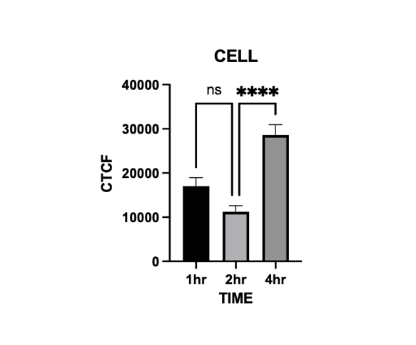
Figure 7. Fiji 1-4h Bar Graphs

4.2 R Results
The CTCF values ​​obtained after automatic analysis of the same batch of images using the R platform were generally consistent with the Fiji results, and the temporal change trends were similar. In the 1-hour group, the R method produced a wide range of CTCF values—from a low of about 1,400 to a high of about 78,000 (see Table 2). This range is significantly wider than that of Fiji, mainly due to the presence of an abnormally high intensity value for a single ROI in the R measurement. Apart from this outlier, most of the R values ​​for the 1-hour groups also fall into the tens of thousands, which is comparable to the Fiji data. The 2-hour group analyzed by R also showed a more dispersed distribution of CTCF values ​​(approximately between 4,200 and 38,000), and its average value was again slightly lower than that of the 1-hour group (Table 2). This result is consistent with the findings of the Fiji method, which also suggests that the average fluorescence intensity shows a slight decrease or plateau at about 2 hours of treatment.
By the 4-hour time point, the CTCF values ​​under the R method increased significantly, which is consistent with the trend observed by the Fiji method. There were many ROIs in the 4-hour group in the R analysis with CTCF exceeding 30,000, and some reaching approximately 35,000–40,000 (the highest value was approximately 52,000 in Table 2). This significant improvement at 4 hours is clearly visible in the bar graph of the R results (Figure 8). The bar height of the 4-hour group is much higher than that of the 1-hour and 2-hour groups, and the trend is very similar to the Fiji graph.
Therefore, the analysis of the R method also confirmed the rule that the fluorescence signal increased cumulatively over time. Although there is some variability in the R data and individual outliers, the overall pattern—a slight decrease from the 1- to 2-hour mean and a large increase at 4 hours—is highly consistent with the findings of the Fiji method.
Table 2. R-1hr 2hr 4hr CTCF
1hr | 2hr | 4hr
32182.4 | 8493.58 | 52317.29
78063.6 | 16892.4 | 21043.61
11497.65 | 4198.61 | 18026.93
16046 | 7152.09 | 38982.34
7339.808 | 12058.14 | 35417.58
1391.83 | 4874.11 | 22275.16
8570.922 | 13695.33 | 39734.92
35578.4 | 6284.92 | 29058.45
4346.302 | 7620.58 | 35982.73
2526.187 | 10928.66 | 19523.14
15689.98 | 7581.93 | 24479.86
32903 | 16430.57 | 29916.14
7985.56 | 6051.38 | 13152.29
11155.0933 | 13738.07 | 11986.83
7302.88333 | 9450.33 | 16358.24
3450.67333 | 8392.44 | 41058.17
1401.53667 | 10024.17 | 35241.59
4253.74667 | 6129.87 | 14523.79
8105.95667 | 4328.15 | 17734.96
11958.1667 | 13632.45 | 37941.06
15810.3767 | 8482.51 | 15246.19
19662.5867 | 19483.67 | 36482.75
23514.7967 | 38723.92 | 11274.51
27367.0067 | 13804.48 | 13847.93
31219.2167 | 7742.11 | 28612.48
5071.42667 | 10949.1146 | 26840.4531
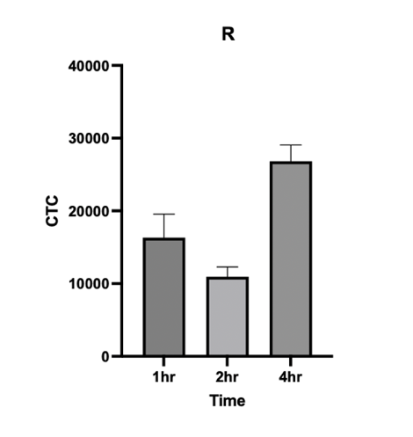
Figure 8. R 1-4h Bar Graphs

4.3 Comparison of Methods R & Fiji
Figure 9 and Table 3 directly compare the CTCF results obtained by the Fiji and R methods at each time point. At 1 hour, the average CTCF values ​​obtained by the two methods are very close (Table 3), and most of the data points are also distributed in a similar range. However, one notable difference in the 1-hour group is that the R method shows an abnormally high value (as mentioned before), which leads to an increase in the variance of the R data set (this is reflected in the length of the error bars of the R column of the 1-hour group in Figure 9). Apart from this extreme case, the values ​​measured by Fiji and R in the 1-hour group were very consistent, indicating that for the initial time point, the two methods produced results that were nearly compatible with each other.
In the 2-hour group, Figure 9 shows that the mean CTCF of Fiji and R are again very close (both are approximately 1.1×10^4). The side-by-side 2-hour histograms are almost equal in height; Table 3 shows that the averages of the two methods differ by only a few hundred units, which is a very small difference. This indicates that at 2 h, there was a high degree of agreement between the two methods, with the automated analysis by R and the manual measurement by Fiji capturing essentially the same changes in fluorescence intensity levels.
In the 4-hour group, CTCF measured by both methods increased significantly, and the results were still highly consistent. In Figure 9, the column heights of Fiji and R in the 4-hour group both reached similar high values ​​(average of about 2.6 –2.8×10^4), and the error ranges also overlapped highly. Any slight difference in the 4-hour values ​​(Table 3 shows that Fiji has a slightly higher mean than R) is minor relative to the overall signal increase.
In summary, the side-by-side comparison of each time point shows that the measurements given by the Fiji and R methods are consistent. The observed trend (consistent initially, a slight drop at 2 hours, and a large increase at 4 hours) was accurately captured by both methods, and there was no obvious systematic bias - that is, at all time points, neither method consistently produced significantly higher or lower CTCF values ​​than the other.
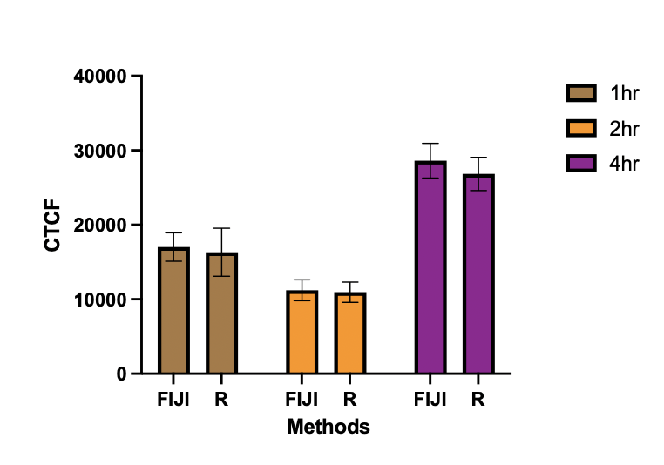
Figure 9. R&Fiji Comparison

Table 3.R&Fiji Comparison
1h_Fiji | 1h_R | 2h_Fiji | 2h_R | 4h_Fiji | 4h_R
18136.12 | 32182.4 | 9672.067 | 8482.51 | 38887.33 | 37632.84
5578.463 | 78063.6 | 10494.51 | 8493.58 | 55660.6 | 52317.29
3539.196 | 11497.65 | 13905.57 | 16892.4 | 22249.82 | 21043.61
10417.75 | 16046 | 20113.23 | 4198.61 | 19539.17 | 18026.93
9989.181 | 7339.808 | 7941.52 | 7152.09 | 40342.24 | 38982.34
15295.81 | 1391.83 | 4458.453 | 12058.14 | 37193.79 | 35417.58
18749.78 | 8570.922 | 7330.4 | 4874.11 | 23736.59 | 22275.16
13987.13 | 35578.4 | 17414.19 | 13695.33 | 42208.7 | 39734.92
8246.848 | 4346.302 | 11175.34 | 6284.92 | 30846.76 | 29058.45
7308.26 | 2526.187 | 7875.467 | 7620.58 | 38554.28 | 35982.73
12864.76 | 15689.98 | 8754.88 | 10928.66 | 21208.95 | 19523.14
41033 | 32903 | 7759.327 | 7581.93 | 26409.67 | 24479.86
5961.204 | 7985.56 | 8604.58 | 16430.57 | 31415.22 | 29916.14
17709.88 | 11155.09 | 6434.087 | 6051.38 | 14365.68 | 13152.29
34350.92 | 7302.883 | 6262.233 | 13738.07 | 12597.91 | 11986.83
18359.6 | 3450.673 | 7882.013 | 9450.33 | 17405.12 | 16358.24
28629.3 | 1401.537 | 16870.43 | 8392.44 | 43496.51 | 41058.17
12320.2 | 4253.747 | 6179.96 | 10024.17 | 37214.93 | 35241.59
19251.98 | 8105.957 | 4300.72 | 6129.87 | 16357.6 | 14523.79
23883.04 | 11958.17 | 12527.46 | 4328.15 | 18776.42 | 17734.96
17153 | 15810.38 | 39903.3 | 13632.45 | 40571.73 | 37941.06
23011.5 | 19662.59 | 14022.59 | 8482.51 | 16559.46 | 15246.19
36510.14 | 23514.8 | 14017.95 | 19483.67 | 39334.49 | 36482.75
21258.94 | 27367.01 | 8705.312 | 38723.92 | 12206.5 | 11274.51
6459.76 | 31219.22 | 14116.02 | 13804.48 | 15687.26 | 13847.93
12537.68 | 5071.427 | 4977.632 | 7742.11 | 31181.99 | 28612.48

4.4 Summary of findings and trends
Looking at the above results, we can clearly see a pattern: CTCF increases with the extension of treatment time. Results from both the Fiji and R methods showed that the corrected fluorescence intensity was low to moderate after 1 h of treatment, comparable or slightly decreased at 2 h, and significantly increased by 4 h. The increase in CTCF over time suggests that the fluorescent signal accumulates during treatment. This is in line with expectations, as many biological processes increase the amount of fluorescently labeled target molecules or amplify the signal over time. Both the quantitative data (see Tables 1–3) and the visualized bar graphs (Figures 7–9) support this trend: CTCF changes little from 1 to 2 hours (a slight decrease), and then increases significantly at 4 hours.
It is noteworthy that the consistency of the results of the two measurement methods adds credibility to the above findings. The manual/semi-automated method of Fiji and the automated analysis of R showed highly similar results in corrected fluorescence intensity, with only minor differences. Minor differences observed (e.g., the R method captured an outlier or the average obtained at 4 h was slightly lower) can be attributed to detailed differences in ROI definition or background subtraction rather than fundamental disagreements in trends. There was no systematic bias in which one method consistently gave higher or lower CTCF than the other; rather, both methods tracked changes in fluorescence over time synchronously. This high level of consistency suggests that the ROI definition and processing pipelines employed in the Fiji and R analyses are well aligned.
In summary, our results demonstrate a robust pattern of significant increases in CTCF with prolonged treatment time and show that the automated R analysis pipeline can reliably reproduce traditional Fiji measurements, further supporting the validity of the observed trends.

5. Discussion

5.1 Advantages and limitations
This study compared two methods for quantitative image analysis—the Fiji image analysis platform and the R programming environment—each with different advantages and limitations. Fiji has a user-friendly interface and a rich plugin ecosystem, which enables common biological image analysis tasks to be completed without programming and allows for quick and easy interactive measurements. In contrast, the R-based approach (using the EBImage package) allows for scripting of analyses, allowing for a reproducible, shareable, and scalable analysis pipeline. R excels at automation and integration with statistical analysis, making it ideal for processing large batches of images or performing complex quantitative analysis tasks. However, Fiji's reliance on manual operations may introduce human bias, and the efficiency of high-throughput analysis is low when macro batch processing is not used; in contrast, R requires programming expertise and has a difficult learning curve for researchers who lack programming experience.

5.2 Current shortcomings
Background inhomogeneities in optical images are a concern: if background correction or normalization is not performed correctly, inhomogeneities in background signal can lead to significant bias in fluorescence intensity measurements. Furthermore, the accuracy of ROI (region of interest) selection has a significant impact on the results - even slight differences in ROI borders can change the measured values. The determination of ROI is often subjective, and manual or semi-automatic delineation processes may introduce operator bias and lead to discrepancies in results. Furthermore, the user's adjustment of analysis parameters (such as threshold settings) may also lead to inconsistent results between different experiments or different operators. These factors will cause errors in experimental results to varying degrees, so it is necessary to strictly standardize various analysis processes (such as using consistent background subtraction methods and ROI definition criteria) to improve the accuracy and repeatability of the results.

5.3 Significance for researchers
The methods and findings of this study have important reference value and significance for researchers in the field of biological image quantitative analysis. By systematically comparing a widely used graphical interface software (Fiji) with a script-based analysis method (R), the trade-off between ease of use of image processing and computational rigor is revealed. The results can provide a reference for others to choose analysis tools: researchers can use our findings to balance the convenience and ease of use of the Fiji method with the high reproducibility of the R method. At the same time, the identification of error sources (background correction problems and ROI differences) has alerted the academic community to common pitfalls in quantitative analysis of fluorescence images. In summary, my work provides practical guidance for improving the accuracy and reliability of image analysis pipelines and emphasizes the importance of combining biological understanding with computational analysis methods.

5.4 Future Development
Looking ahead, increasing the degree of automation in the analysis process should be one of the top priorities for improvement—for example, by using algorithms to automatically perform steps such as ROI detection and background subtraction, thereby reducing bias caused by manual intervention. Another promising direction is to combine the method with deep learning techniques (e.g. using convolutional neural networks for image segmentation), as this will significantly improve the analysis accuracy and help to handle more complex image patterns. In addition, this method should be applied and validated in more complex fluorescence image scenarios, such as multi-channel or three-dimensional images, and images with strong noise or signal overlap, to ensure its robustness and wide applicability. By promoting the above improvements - higher degree of automation, intelligent algorithms and greater adaptability - the efficiency, accuracy and wide applicability of image analysis will be further improved, and the development direction of future research in the field of quantitative analysis of biological images will be pointed out.

6. Conclusions
Quantitative analysis of fluorescence microscopy images is a fundamental task for understanding cellular processes, but obtaining consistent and reproducible results is challenging. Different image analysis methods and researcher experience often lead to inconsistent measurements, highlighting the need to establish standardized analysis methods. For example, manual quantification is time-consuming and subjective, while automated analysis through programming can objectively process large data sets but requires specialized technical skills. Therefore, in order to solve these problems, Fiji manual analysis and R language automatic analysis were used for comparison to evaluate the CTCF intensity measured by the two methods in the same ROI.
In this experiment, cell fluorescence images were used at 1 hour, 2 hours, and 4 hours. All images used the same ROI and background area to ensure consistency. The final result showed that CTCF showed an upward trend within 1-4 hours, indicating that the fluorescence intensity increased with time. At the same time, it was found that the CTCF obtained by Fiji and R showed an increasing trend and the values ​​were basically consistent, indicating that the two methods have good consistency.
The high consistency of the results from the Fiji and R analyses not only validates the reliability of each method but also demonstrates the feasibility of combining ease of use with high-throughput technology. This study contributes to the standardization of fluorescence image quantification by providing a validated analytical framework that can be adopted by others to obtain reproducible results.

7. Recommendations
In light of the above findings, we propose the following key recommendations to guide future practice of fluorescence image quantification:
For novice researchers, Fiji software is recommended because of its intuitive graphical interface, which is suitable for teaching training and low-throughput analysis. Its user-friendly interface enables beginners to carry out image quantification smoothly even if they lack rich technical background. In contrast, R programming methods are more suitable for automated and high-throughput large-scale image data analysis and provide powerful batch processing functions. Therefore, beginners can start with the easy-to-use Fiji, while experienced researchers can use R scripts to efficiently handle large studies.
The selection of background ROIs should be kept consistent across all images and experiments, either by defining a fixed reference region or by using a uniform selection criteria.

References
Abdullah, M. Z. (2016). Image acquisition systems. In D.-W. Sun (Ed.), Computer vision technology for food quality evaluation (2nd ed., pp. 3–43). Academic Press. https://doi.org/10.1016/B978-0-12-802232-0.00001-3
Boehm, U., Nelson, G., Brown, C. M., Bagley, S., Bajcsy, P., Bischof, J., ... & Nitschke, R. (2021). QUAREP-LiMi: A community endeavor to advance quality assessment and reproducibility in light microscopy. Nature Methods, 18(12), 1423–1426. https://doi.org/10.1038/s41592-021-01162-y
Bray, M. A., Singh, S., Han, H., Davis, C. T., Borgeson, B., Hartland, C., ... & Carpenter, A. E. (2016). Cell Painting, a high-content image-based assay for morphological profiling using multiplexed fluorescent dyes. Nature Protocols, 11(9), 1757–1774. https://doi.org/10.1038/nprot.2016.105
Buchser, W., Collins, M., Garyantes, T., Guha, R., Haney, S., Lemmon, V., ... & Trask, O. J. (2014). Assay development guidelines for image-based high content screening, high content analysis and high content imaging. In Sittampalam, G. S., Coussens, N. P., Brimacombe, K., et al. (Eds.), Assay guidance manual [Internet]. Eli Lilly & Company and the National Center for Advancing Translational Sciences. https://www.ncbi.nlm.nih.gov/books/NBK100913/
Carpenter, A. E., Jones, T. R., Lamprecht, M. R., Clarke, C., Kang, I. H., Friman, O., Guertin, D. A., Chang, J. H., Lindquist, R. A., Moffat, J., Golland, P., & Sabatini, D. M. (2006). CellProfiler: Image analysis software for identifying and quantifying cell phenotypes. Bioinformatics, 22(11), 1406–1412. https://doi.org/10.1093/bioinformatics/btq046
Chu, Z., LaSance, K., Blanco, V., Kwon, C. H., Kaur, B., Frederick, M., Thornton, S., Lemen, L., & Qi, X. (2014). In vivo optical imaging of brain tumors and arthritis using fluorescent SapC-DOPS nanovesicles. Journal of Visualized Experiments (JoVE), (87), e51187. https://doi.org/10.3791/51187
Di Carlo, D., & Lee, L. P. (2006). Dynamic single-cell analysis for quantitative biology. Analytical Chemistry, 78(23), 7918–7925. https://doi.org/10.1021/ac069490p
Dunn, K. W., Kamocka, M. M., & McDonald, J. H. (2011). A practical guide to evaluating colocalization in biological microscopy. American Journal of Physiology-Cell Physiology, 300(4), C723–C742. https://doi.org/10.1152/ajpcell.00462.2010
Eppel, S. (2018). Classifying a specific image region using convolutional nets with an ROI mask as input. arXiv preprint arXiv:1812.00291. https://arxiv.org/abs/1812.00291
Giorgi, F. M., Ceraolo, C., & Mercatelli, D. (2022). The R language: An engine for bioinformatics and data science. Life (Basel, Switzerland), 12(5), 648. https://doi.org/10.3390/life12050648
Hagiwara, A., Fujita, S., Ohno, Y., & Aoki, S. (2020). Variability and standardization of quantitative imaging: Monoparametric to multiparametric quantification, radiomics, and artificial intelligence. Investigative Radiology, 55(9), 601–616. https://doi.org/10.1097/RLI.0000000000000666
Hamilton, N. (2009). Quantification and its applications in fluorescent microscopy imaging. Traffic, 10(8), 951–961. https://doi.org/10.1111/j.1600-0854.2009.00938.x
Hobson, C. M., Guo, M., Vishwasrao, H. D., Wu, Y., Shroff, H., & Chew, T. L. (2022). Practical considerations for quantitative light sheet fluorescence microscopy. Nature Methods, 19(12), 1538–1549. https://doi.org/10.1038/s41592-022-01632-x
Hoogstins, C., Burggraaf, J. J., Koller, M., Handgraaf, H., Boogerd, L., van Dam, G., Vahrmeijer, A., & Burggraaf, J. (2019). Setting standards for reporting and quantification in fluorescence-guided surgery. Molecular Imaging and Biology, 21(1), 11–18. https://doi.org/10.1007/s11307-018-1220-0
Jiang, G., Wang, Z., & Liu, H. (2015). Automatic detection of crop rows based on multi-ROIs. Expert Systems with Applications, 42(5), 2429–2441.
Kichuk, T. C. (2023). Form and function: Development and application of a 3D rendering-based method for analysis of mitochondrial morphology and subcellular architecture (Doctoral dissertation, Princeton University). ProQuest Dissertations Publishing.
Krak, N. C., Boellaard, R., Hoekstra, O. S., Twisk, J. W., Hoekstra, C. J., & Lammertsma, A. A. (2005). Effects of ROI definition and reconstruction method on quantitative outcome and applicability in a response monitoring trial. European Journal of Nuclear Medicine and Molecular Imaging, 32, 294–301. https://doi.org/10.1007/s00259-004-1566-1
Loukas, C. G., Wilson, G. D., Vojnovic, B., & Linney, A. (2003). An image analysis‐based approach for automated counting of cancer cell nuclei in tissue sections. Cytometry Part A: The Journal of the International Society for Analytical Cytology, 55(1), 30–42. https://doi.org/10.1002/cyto.a.10060
Mousavi, S. M., Naghsh, A., & Abu-Bakar, S. A. (2015). A heuristic automatic and robust ROI detection method for medical image watermarking. Journal of Digital Imaging, 28(4), 417–427. https://doi.org/10.1007/s10278-015-9770-z
Nelson, G., Gelman, L., Faklaris, O., Nitschke, R., & Laude, A. (2020). Interpretation of Confocal ISO 21073:2019 confocal microscopes: Optical data of fluorescence confocal microscopes for biological imaging—Recommended methodology for quality control. arXiv Preprint, arXiv:2011.08713. https://arxiv.org/abs/2011.08713
Nieto-Castanon, A., Ghosh, S. S., Tourville, J. A., & Guenther, F. H. (2003). Region of interest based analysis of functional imaging data. NeuroImage, 19(4), 1303–1316. https://doi.org/10.1016/S1053-8119(03)00188-5
Oberholzer, M., Östreicher, M., Christen, H., & Brühlmann, M. (1996). Methods in quantitative image analysis. Histochemistry and Cell Biology, 105, 333–355. https://doi.org/10.1007/BF01463655
Pau, G., Fuchs, F., Sklyar, O., Boutros, M., & Huber, W. (2010). EBImage—an R package for image processing with applications to cellular phenotypes. Bioinformatics, 26(7), 979–981. https://academic.oup.com/bioinformatics/article/26/7/979/211835
Petty, H. R. (2007). Fluorescence microscopy: Established and emerging methods, experimental strategies, and applications in immunology. Microscopy Research and Technique, 70(8), 687–709. https://doi.org/10.1002/jemt.20455
Sasaki, A. (2022). Recent advances in the standardization of fluorescence microscopy for quantitative image analysis. Biophysical Reviews, 14(1), 33–39. https://doi.org/10.1007/s12551-021-00871-0
Schindelin, J., Arganda-Carreras, I., Frise, E., Kaynig, V., Longair, M., Pietzsch, T., Preibisch, S., Rueden, C., Saalfeld, S., Schmid, B., Tinevez, J. Y., White, D. J., Hartenstein, V., Eliceiri, K., Tomancak, P., & Cardona, A. (2012). Fiji: An open-source platform for biological-image analysis. Nature Methods, 9(7), 676–682. https://doi.org/10.1038/nmeth.2019
Schmied, J. J., Raab, M., Forthmann, C., Pibiri, E., Wünsch, B., Dammeyer, T., & Tinnefeld, P. (2014). DNA origami–based standards for quantitative fluorescence microscopy. Nature Protocols, 9(6), 1367–1391. https://www.nature.com/articles/nprot.2014.079
Shihan, M. H., Novo, S. G., Le Marchand, S. J., Wang, Y., & Duncan, M. K. (2021). A simple method for quantitating confocal fluorescent images. Biochemistry and Biophysics Reports, 25, 100916. https://doi.org/10.1016/j.bbrep.2021.100916
Sinhal, R., Sharma, S., Ansari, I. A., & Bajaj, V. (2022). Multipurpose medical image watermarking for effective security solutions. Multimedia Tools and Applications, 81(10), 14045–14063. https://doi.org/10.1007/s11042-022-12082-0
Sklyar, O., & Huber, W. (2008). Introduction to EBImage, an image processing and analysis toolkit for R. DIM (iG), 1(508), 508.
Smal, I., Loog, M., Niessen, W., & Meijering, E. (2010). Quantitative comparison of spot detection methods in fluorescence microscopy. IEEE Transactions on Medical Imaging, 29(2), 282–301. https://doi.org/10.1109/TMI.2009.2025127
Stossi, F., & Singh, P. K. (2023). Basic image analysis and manipulation in ImageJ/Fiji. Current Protocols, 3(7), e849. https://doi.org/10.1002/cpz1.849
Suzuki, T., Matsuzaki, T., Hagiwara, H., Aoki, T., & Takata, K. (2007). Recent advances in fluorescent labeling techniques for fluorescence microscopy. Acta Histochemica et Cytochemica, 40(5), 131–137. https://doi.org/10.1267/ahc.07023
Tsikritsis, D., Legge, E. J., & Belsey, N. A. (2022). Practical considerations for quantitative and reproducible measurements with stimulated Raman scattering microscopy. Analyst, 147(21), 4642–4656. https://doi.org/10.1039/d2an00817c
Vosatka, K. W., Lavenus, S. B., & Logue, J. S. (2022). A novel Fiji/ImageJ plugin for the rapid analysis of blebbing cells. PLOS ONE, 17(4), e0267740. https://doi.org/10.1371/journal.pone.0267740
Waters, J. C. (2009). Accuracy and precision in quantitative fluorescence microscopy. Journal of Cell Biology, 185(7), 1135–1148. https://doi.org/10.1083/jcb.200903097
Wolf, D. E. (2007). Fundamentals of fluorescence and fluorescence microscopy. Methods in Cell Biology, 81, 63–91. https://www.sciencedirect.com/science/article/abs/pii/S0091679X06810058

Appendix II: R Code

1.library(EBImage)
library(RImageJROI)
library(sp)
library(dplyr)
2. image_path <- "/ Image Path "
cat("Reading an Image：", image_path, "\n")
color_img <- readImage(image_path)
img_range <- range(color_img)
cat("Original image value range: ", img_range, "\n")
if(max(color_img) <= 1) {
color_img <- color_img * 255
cat("The image values ​​have been multiplied by 255\n")
}
Extract green channel
green_img <- channel(color_img, "green")
cat("Green channel dimensions: ", dim(green_img), "\n\n")
3. Define a function to generate a polygonal ROI mask
create_polygon_mask <- function(roi_obj, ref_img) {
if (!is.list(roi_obj$coords)) {
coords_vec <- roi_obj$coords
n <- length(coords_vec)
x_coords <- coords_vec[seq(1, n, by = 2)]
y_coords <- coords_vec[seq(2, n, by = 2)]
} else {
x_coords <- roi_obj$coords$x
y_coords <- roi_obj$coords$y
}

w <- dim(ref_img)[1]
h <- dim(ref_img)[2]

mask <- Image(0, dim = c(w, h))
grid <- expand.grid(x = 0:(w - 1), y = 0:(h - 1))

inside_vec <- sp::point.in.polygon(grid$x, grid$y, x_coords, y_coords)
pts_in <- grid[inside_vec != 0, ]

for (i in seq_len(nrow(pts_in))) {
mask[pts_in$x[i] + 1, pts_in$y[i] + 1] <- 1
}

return(mask)
}
4. Define a function to calculate ROI statistics
compute_roi_stats <- function(roi_path, ref_img) {
roi_obj <- RImageJROI::read.ijroi(roi_path)
shape <- tolower(roi_obj$strType) # For example "polygon"

# Only process polygon ROI; if it is not a polygon, skip it
if (shape != "polygon") {
warning("Skipping non-polygon ROI: ", roi_path, " (type=", roi_obj$strType, ")")
return(NULL)
}

Generate ROI mask
mask <- create_polygon_mask(roi_obj, ref_img)

Extract pixel values ​​from ROI area
roi_pixels <- ref_img[mask == 1]
area_px <- length(roi_pixels)
mean_intensity <- mean(roi_pixels)
min_intensity <- min(roi_pixels)
max_intensity <- max(roi_pixels)
int_density <- sum(roi_pixels)
（IntDen）
raw_int_density <- int_density

data.frame(
roi_file = roi_path,
roi_strType = roi_obj$strType,
area = area_px,
mean_intensity = mean_intensity,
min_intensity = min_intensity,
max_intensity = max_intensity,
int_density = int_density,
raw_int_density = raw_int_density,
stringsAsFactors = FALSE
)
}
5．roi_dir <- "/Users/bianrumo/Desktop/RoiSet"
cat("ROI File：", roi_dir, "\n")
roi_files <- list.files(roi_dir, pattern = "\\.roi$", full.names = TRUE)

install.packages(c("EBImage", "RImageJROI", "sp", "dplyr"))
roi_dir <- "/Users/bianrumo/Desktop/RoiSet"

roi_files <- list.files(roi_dir, pattern = "\\.roi$", full.names = TRUE)

rois_df <- data.frame(
roi_path = roi_files,
roi_type = ifelse(grepl("bg", basename(roi_files), ignore.case = TRUE), "Background", "Cell"),
stringsAsFactors = FALSE
)

print(rois_df)

6. measure_list <- lapply(seq_len(nrow(rois_df)), function(i) {
rowi <- rois_df[i, ]
stats <- compute_roi_stats(rowi$roi_path, green_img)
#
if (!is.null(stats)) {
stats$roi_type <- rowi$roi_type
}
stats
})

measure_df <- do.call(rbind, measure_list)
cat("ROI Result：\n")
print(measure_df)

library(dplyr)
7. CTCF
bg_summary <- measure_df %%
filter(roi_type == "Background") %%
summarise(bg_mean = mean(mean_intensity, na.rm = TRUE))
bg_mean <- bg_summary$bg_mean
cat("ROI=", bg_mean, "\n\n")
CTCF result
CTCF = int_density - (area × bg_mean)
final_df <- measure_df %%
mutate(CTCF = ifelse(roi_type == "Cell",
int_density - (area * bg_mean),
NA))
cat("Final Result：\n")
print(final_df)
8. Export Results
write.csv(final_df, file = "roi_ctcf_result.csv", row.names = FALSE)
cat("roi_ctcf_result.csv\n\n"

